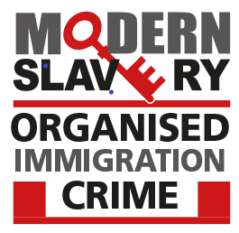

Lived Experience Advisory Panel
By email to – Jasmine Selby, Communications Lead at the Human Trafficking Foundation jasmine@humantraffickingfoundation.org

20th March 2023

Re: Reviewing the Victims Section of the Guide: The Investigative Opportunities for Offences Under the MSA 2015
In April last year the Modern Slavery Organised Immigration Crime Unit (MSOICU) received numerous deliverables from the Home Office to complete in this 12-month period. One of those deliverables was to update national guidance to UK law enforcement for investigating modern slavery cases.
To capture the voices and learning from survivors of modern slavery crimes I was delighted to hear that the Lived Experience Advisory Panel were able to take time to share their experiences and expertise with our unit. The information and insights they have shared and provided the unit is invaluable to our work and I would be most grateful if you could please pass on my thanks to the independent consultants that took part.

Kind regards,

Det Supt Tamasine Matthews
Unit Head
Modern Slavery Organised Immigration Crime Unit

